作业十五：单臂路由跨VLAN配置

第一步：设计并连线
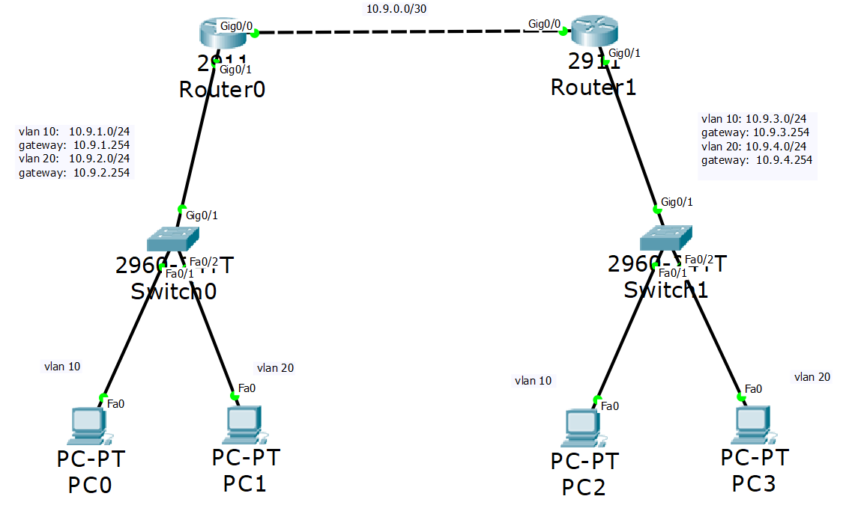

第二步：配置VLAN交换机
- Switch 0和1相同的配置
Switch>en
Switch#conf t
Switch(config)#vlan 10
Switch(config-vlan)#vlan 20
Switch(config-vlan)#int f0/1
Switch(config-if)#sw mode access
Switch(config-if)#sw access vlan 10
Switch(config-if)#int f0/2
Switch(config-if)#sw mode access
Switch(config-if)#sw access vlan 20
Switch(config-if)#int g0/1
Switch(config-if)#sw mode trunk

第三步：路由器端口配置
- Router 0配置
Router1(config)# interface g0/1
Router1(config-if)# no shutdown
Router1(config)# interface g0/1.10
Router1(config-subif)# encapsulation dot1Q 10
Router1(config-subif)# ip address 10.9.1.254 255.255.255.0
Router1(config)# interface g0/1.20
Router1(config-subif)# encapsulation dot1Q 20
Router1(config-subif)# ip address 10.9.2.254 255.255.255.0
Router1(config)# interface g0/0
Router1(config-if)# ip address 10.9.0.1 255.255.255.252
Router1(config-if)# no shutdown

- Router 1配置
Router2(config)# interface g0/1
Router2(config-if)# no shutdown
Router2(config)# interface g0/1.10
Router2(config-subif)# encapsulation dot1Q 10
Router2(config-subif)# ip address 10.9.3.254 255.255.255.0
Router2(config)# interface g0/1.20
Router2(config-subif)# encapsulation dot1Q 20
Router2(config-subif)# ip address 10.9.4.254 255.255.255.0
Router2(config)# interface g0/0
Router2(config-if)# ip address 10.9.0.2 255.255.255.252
Router2(config-if)# no shutdown

第四步：DHCP配置
- Router 0配置
Router1(config)# ip dhcp excluded-address 10.9.1.254
Router1(config)# ip dhcp excluded-address 10.9.2.254
Router1(config)# ip dhcp pool VLAN10_L
Router1(dhcp-config)# network 10.9.1.0 255.255.255.0
Router1(dhcp-config)# default-router 10.9.1.254
Router1(config)# ip dhcp pool VLAN20_L
Router1(dhcp-config)# network 10.9.2.0 255.255.255.0
Router1(dhcp-config)# default-router 10.9.2.254

- Router 1配置
Router2(config)# ip dhcp excluded-address 10.9.3.254
Router2(config)# ip dhcp excluded-address 10.9.4.254
Router2(config)# ip dhcp pool VLAN10_R
Router2(dhcp-config)# network 10.9.3.0 255.255.255.0
Router2(dhcp-config)# default-router 10.9.3.254
Router2(config)# ip dhcp pool VLAN20_R
Router2(dhcp-config)# network 10.9.4.0 255.255.255.0
Router2(dhcp-config)# default-router 10.9.4.254
- PC 0为例
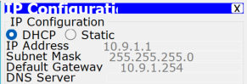

第五步：RIP配置
- Router 0配置
Router1(config)# router rip
Router1(config-router)# version 2
Router1(config-router)# network 10.0.0.0

- Router 1配置
Router2(config)# router rip
Router2(config-router)# version 2
Router2(config-router)# network 10.0.0.0

